AWS Console Login Page: http://aws.amazon.com/console/

1.Click ( Sign in to the AWS Console)
2.Type Email address (select returning customer)and password (Sign in)

Selecting Ec2 Instance:
- Services -> compute (All Aws Services) --> Ec2 (click)

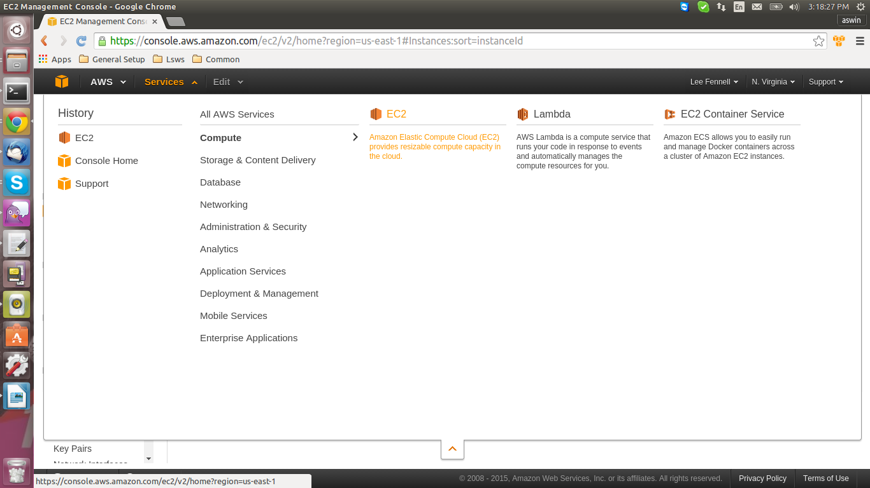
- Click Instances in Ec2 Dashboard

Instance creation:

- Step 1 : From the console dashboard, click Launch Instance.

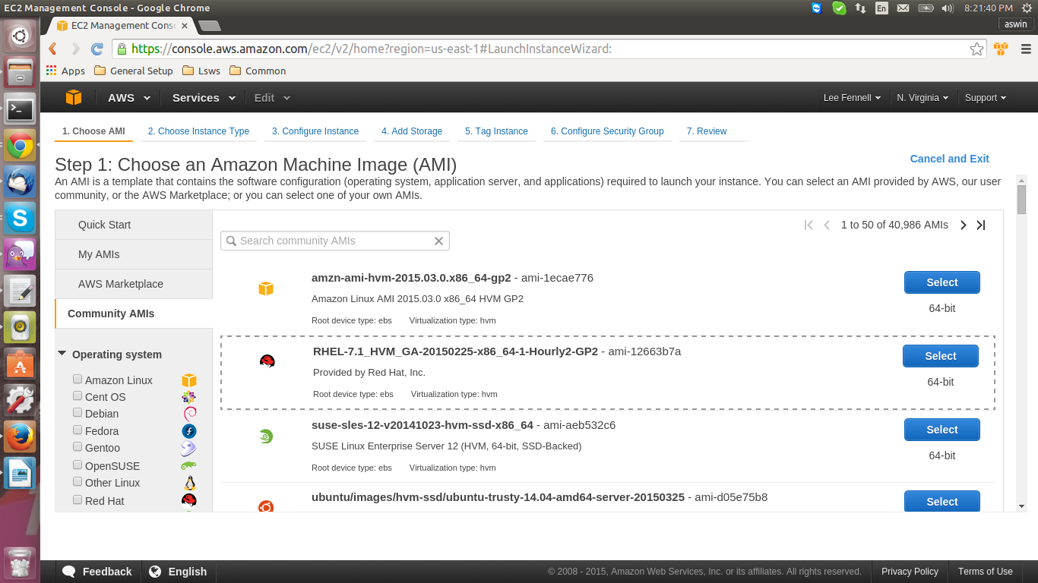
- Step 2 : Choose your AMIs from Community AMIs. (RHEL-7.1_HVM_GA-20150225-x86_64-1-Hourly2-GP2 – ami-12663b7a )

- Step 3 :Choose your instance type and Configure Instance (Next: Configure Instance Details)

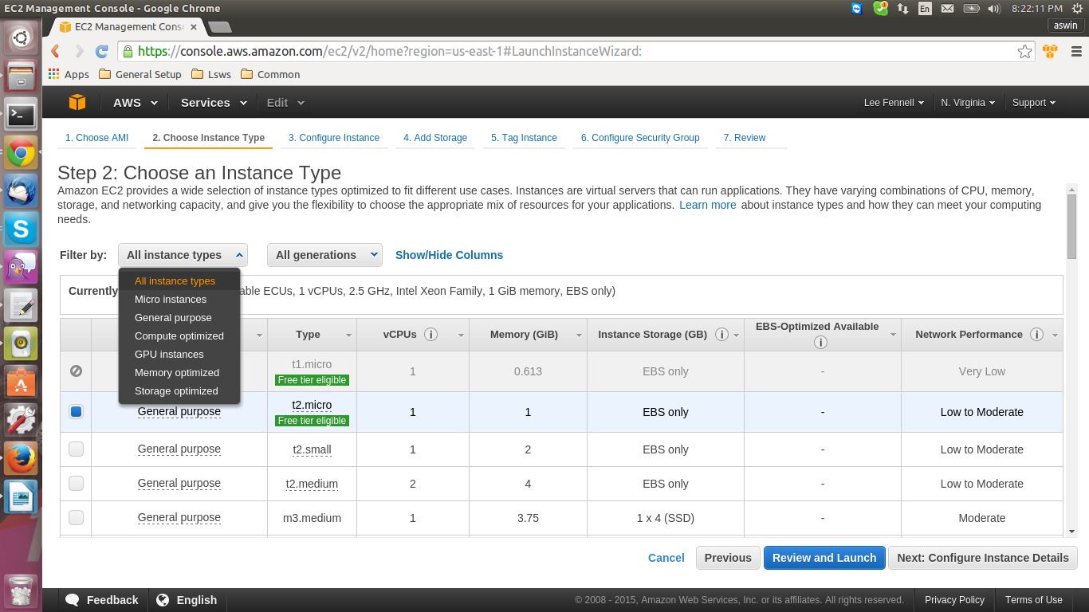

- Step 4 : Add storage [ Here we can set size for root Directory and select volume type then we can Add New volume based on our Purpose ]
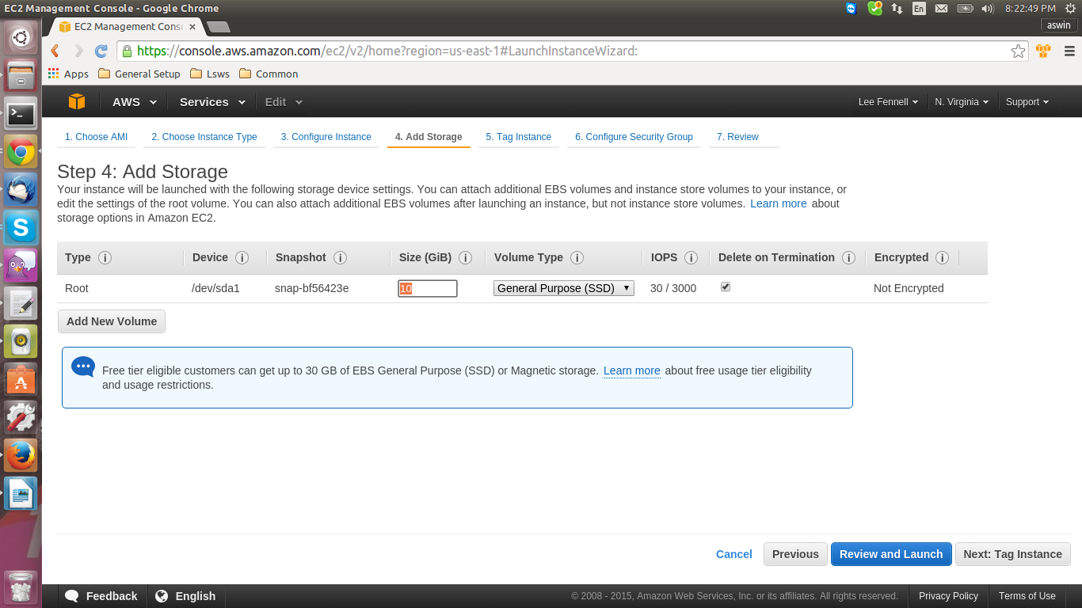

- Step 5 : Configure Secuity Group [ A security group is a set of firewall rules that control the traffic for your instance. On this page, you can add rules to allow specific traffic to reach your instance. For example, if you want to set up a web server and allow Internet traffic to reach your instance, add rules that allow unrestricted access to the HTTP and HTTPS ports. You can create a new security group or select from an existing one ]

- Step 6 : Review your AMIs Details, Instance type, Security Groups, Instance Details and Storage [ You can go back to edit changes for each section. ]

To create and attach an Amazon EBS volume :

- Open the Amazon EC2 console at https://console.aws.amazon.com/ec2/.

- In the navigation bar, select the region in which you created your instance, and then click Instances in the navigation pane.

- The console displays the list of current instances in that region. Select your Linux instance. In the Description tab in the bottom pane note the Availability Zone for the instance.

In the navigation pane, under Elastic Block Store, click Volumes.

Click Create Volume.

Configure the following, and then click Create:

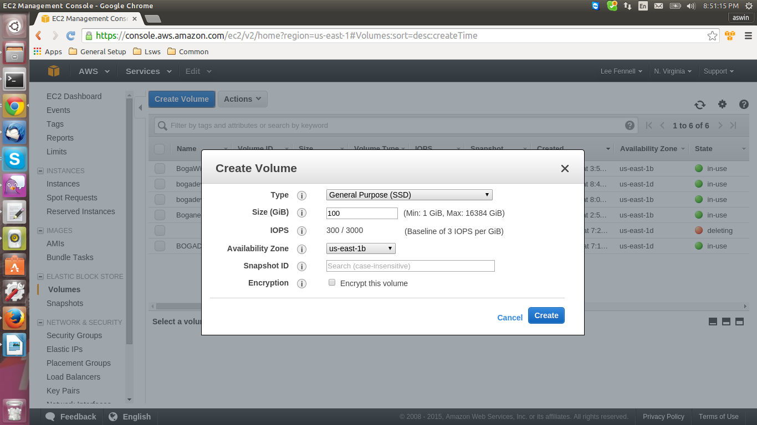

Select the General Purpose (SSD) volume type to create a General Purpose (SSD) EBS volume.

Note
Some AWS accounts created before 2012 might have access to Availability Zones in us-east-1, us-west-1, or ap-northeast-1 that do not support SSD volumes such as Provisioned IOPS (SSD) and General Purpose (SSD). If you are unable to create an SSD volume (or launch an instance with an SSD volume in its block device mapping) in one of these regions, try a different Availability Zone in the region. You can verify that an Availability Zone supports General Purpose (SSD) and Provisioned IOPS (SSD) volumes by creating a 1 GiB General Purpose (SSD) volume in that zone.

Enter the size of the volume you want to create. The free tier benefits for Amazon EBS include up to 30 GiB of storage; therefore, to avoid being charged for this tutorial, choose a volume size that will keep you from exceeding that limit. For example, if the boot volume for the instance you created uses an 8 GiB Amazon EBS volume, then make sure to create a volume that is less than or equal to 22 GiB.

- Select the same Availability Zone that you used when you created your instance. Otherwise, you can't attach the volume to your instance.

- In the navigation pane, under Elastic Block Store, click Volumes. Notice that your newly created volume appears there and the state of the volume is available, so it's ready to be attached to an instance.

- Right-click the newly created volume and select Attach Volume.

- In the Attach Volume dialog box, configure the following, and then click Attach:

Start typing in the name or ID of your instance, then select it from the list of suggested options.

Specify an unused device name for that instance. We'll use /dev/sdf in this tutorial. If you select a different device name, be sure to note it as you'll need this information in the next procedure.

How to Mount a new attached volume in server :

In this example, there is an empty volume with no partition, so you will mount /dev/xvdf.

- [ec2-user ~]$ lsblk
NAME MAJ:MIN RM SIZE RO TYPE MOUNTPOINT
xvdf 202:80 0 22G 0 disk
xvda1 202:1 0 8G 0 disk /

Format your partition with ext4: sudo mkfs -t ext4 /dev/xvdf

To mount the device as /mnt/my-data, run the following commands.

*Creating Directory

sudo mkdir /mnt/my-data

*Mount Volume in created Directory

sudo mount /dev/xvdf /mnt/my-data

*Now you can run the df -h command, you'll see output like the following.

- [ec2-user ~]$ df -h
Filesystem Size Used Avail Use% Mounted on
/dev/xvda1 7.9G 1.1G 6.8G 14% /
tmpfs 298M 0 298M 0% /dev/shm
/dev/xvdf 22G 0 22G 0% /mnt/my-data

*To view the contents of the new volume, run the following command.

- [ec2-user ~]$ ls /mnt/my-data

Backup and Recovery:

Creating a snapshot from existing volume:

- Open the Amazon EC2 console and In the navigation pane, click Volumes.
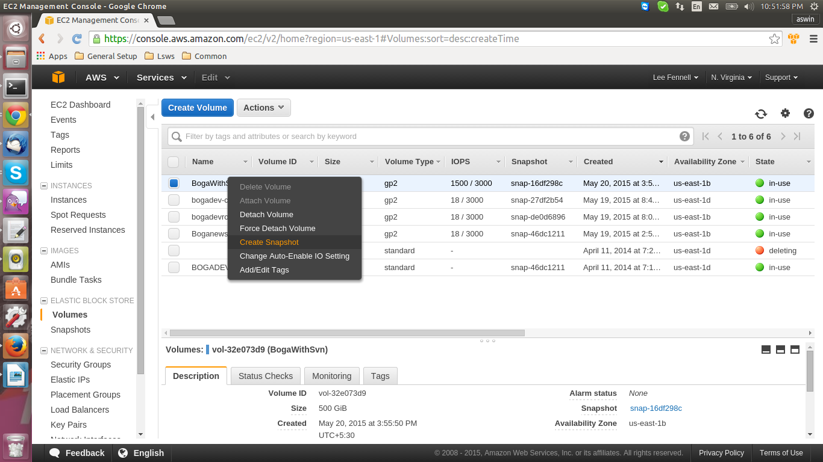

- Select the volume to create snapshot, and then select Create snapshot from the Actions list.
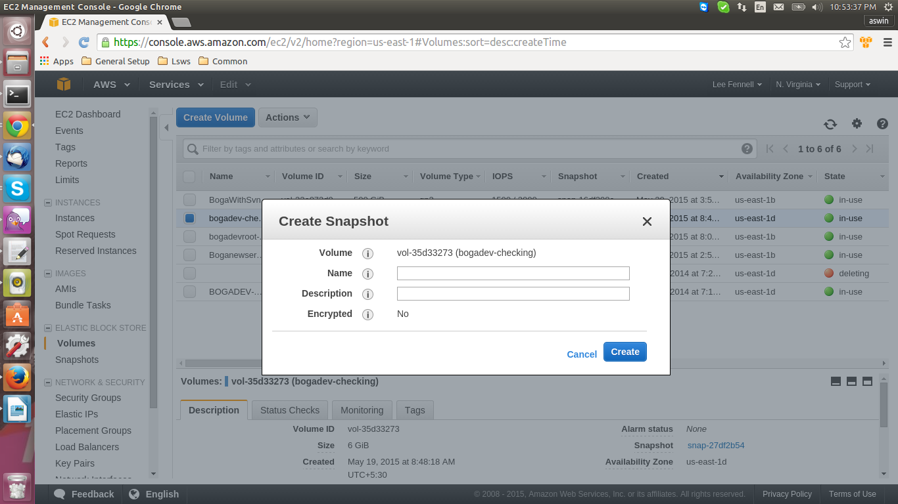
Give the name Snapshot and description.

Adding Volume from created snapshot:

- Open the Amazon EC2 console and In the navigation pane, click Snapshot.

- Select the Snapshot to create volume, and then select Create volume from the Actions list.

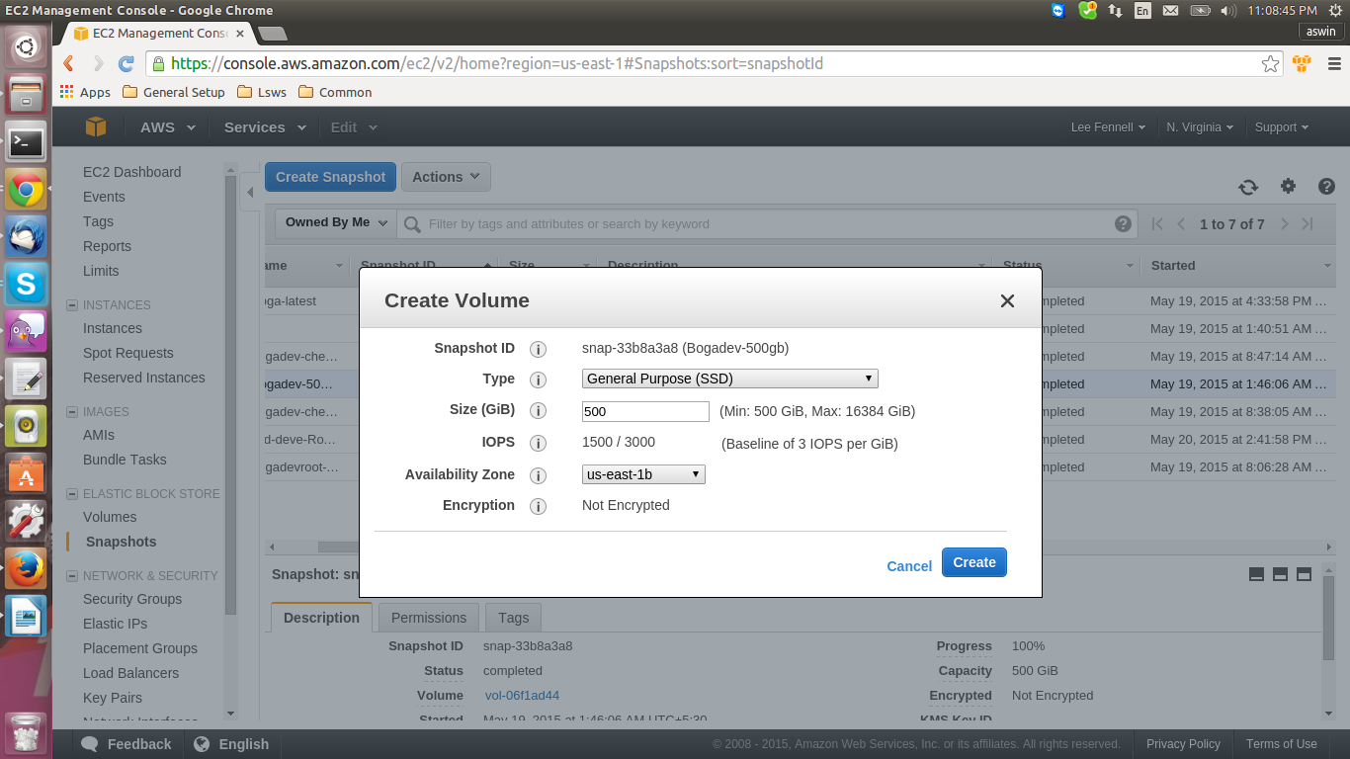
Note:
Some AWS accounts created before 2012 might have access to Availability Zones in us-east-1, us-west-1, or ap-northeast-1 that do not support SSD volumes such as Provisioned IOPS (SSD) and General Purpose (SSD). If you are unable to create an SSD volume (or launch an instance with an SSD volume in its block device mapping) in one of these regions, try a different Availability Zone in the region. You can verify that an Availability Zone supports General Purpose (SSD) and Provisioned IOPS (SSD) volumes by creating a 1 GiB General Purpose (SSD) volume in that zone.

Attach an EBS volume to an instance using the console:

Prerequisites

- Determine the device names that you'll use. For more information, see Device Naming on Linux Instances.

- Determine how many volumes you can attach to your instance. For more information, see Instance Volume Limits.

- If a volume is encrypted, it can only be attached to an instance that supports Amazon EBS encryption. For more information, see Supported Instance Types.

- The volume can only be attached to a stopped instance.

- The configuration (instance type, operating system) of the instance must support that specific AWS Marketplace code. For example, you cannot take a volume from a Windows instance and attach it to a Linux instance.

- Click Volumes in the navigation pane.

- Select a volume and then click Attach Volume.

- In the Attach Volume dialog box, start typing the name or ID of the instance to attach the volume to in the Instance box, and select it from the list of suggestion options (only instances that are in the same Availability Zone as the volume are displayed).

- You can keep the suggested device name, or enter a different supported device name.

- Click Attach.

Important
The block device driver for the instance assigns the actual volume name when mounting the volume, and the name assigned can be different from the name that Amazon EC2 recommends.

Reference:
http://docs.aws.amazon.com/AWSEC2/latest/UserGuide/EC2_GetStarted.html

